Jenkins task -2
Task Description:

Create a simple script file and push it to repo. Create a project in Jenkins connected to your GitHub repository. When a commit is made to your repo, automatically build must get triggered from Jenkins and the output must be shared to me via email.

Added a python script file to my repo
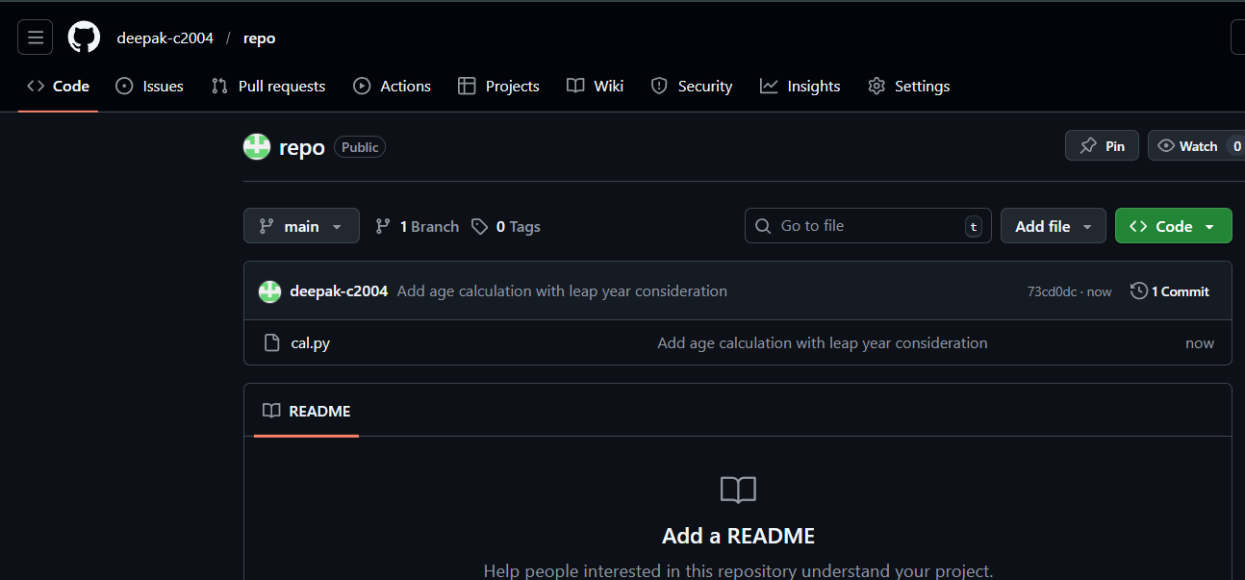

Created pipeline project and connected it to my repo
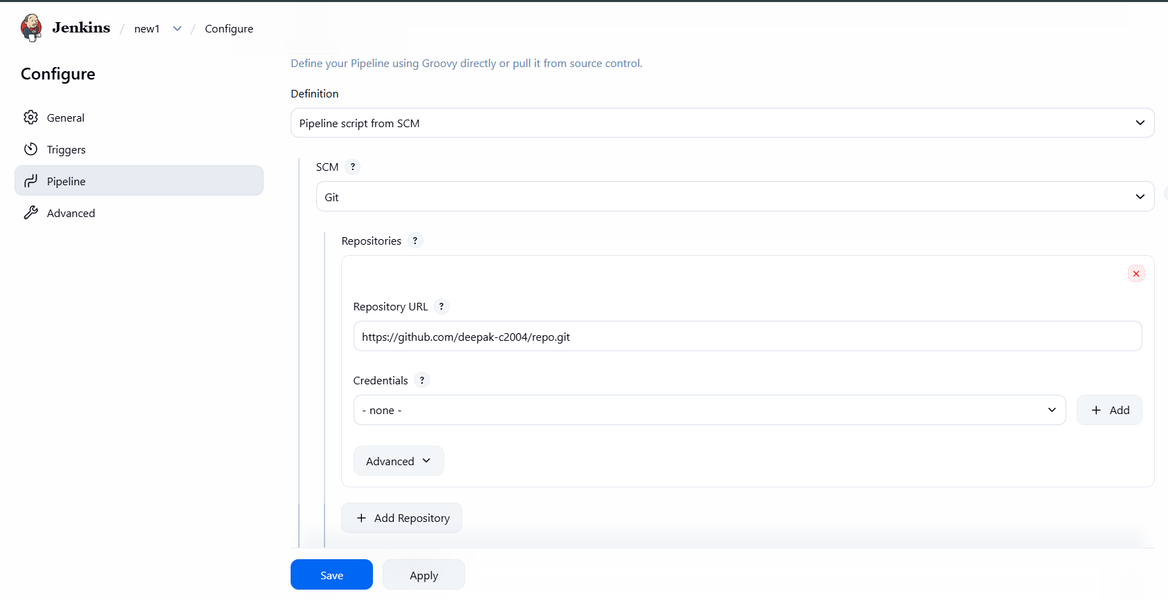
And Created a webhook in my repo 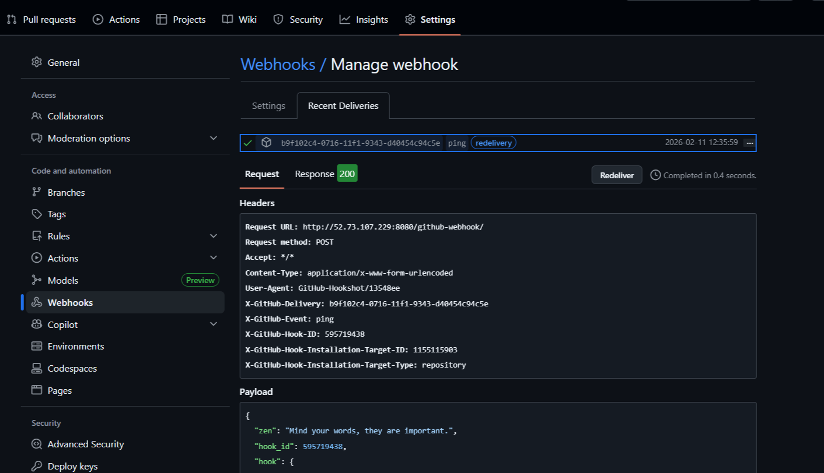

Whenever I made a commit in my repo, the build get automatically triggered
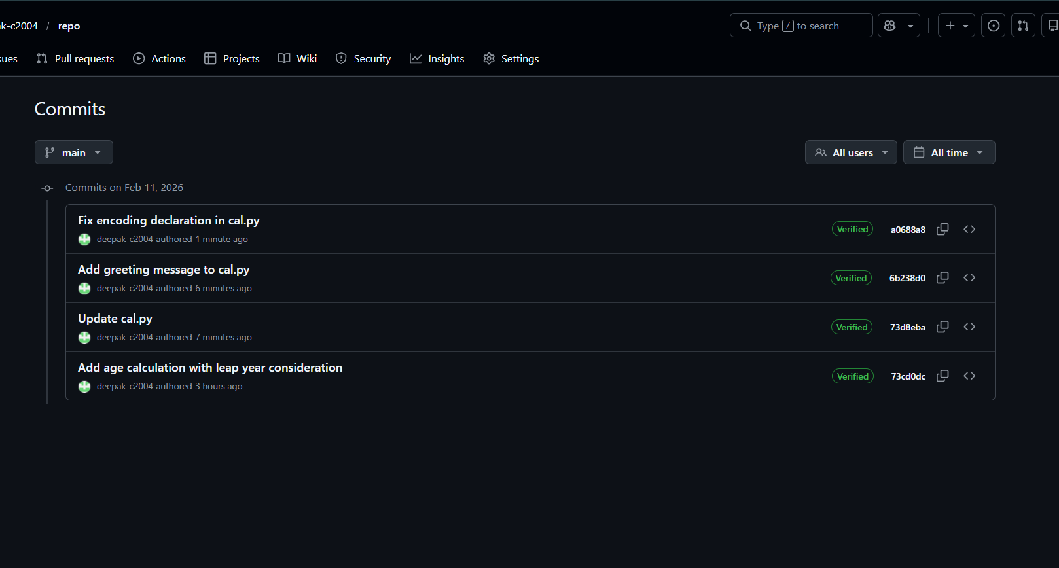
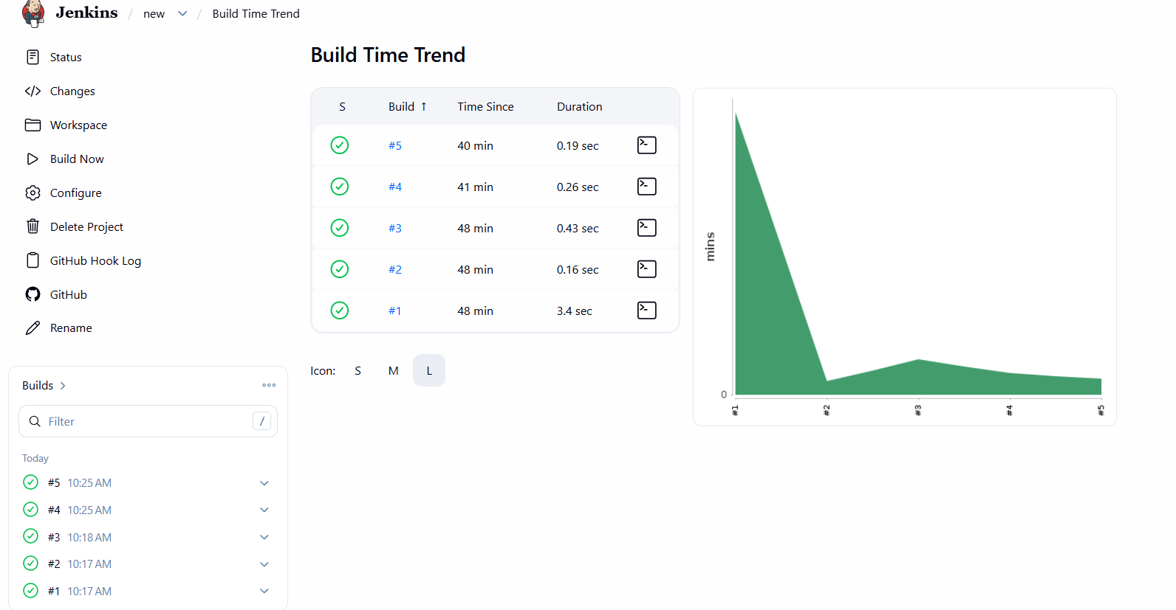

After that I configured smpt server to receive mail whenever a job is triggered
